**Retail Sales Dataset Analysis: Key Insights**

**Introduction:**

This report summarizes the key insights derived from the analysis of the retail sales dataset.

The analysis aimed to uncover trends, patterns, and correlations within the data to provide a better understanding of customer behaviour and sales performance.

**Dataset Overview:**

The dataset contains information on retail transactions, including Transaction ID, Date, Age, Customer ID, Gender, Product Category, Quantity, Price per Unit, and Total Amount.

The analysis focused on exploring relationships between these variables to extract meaningful insights.

**Data Cleaning and Preprocessing:**

The dataset does not contain null values or missing values.

Column names were renamed for better readability and consistency.

The 'Order Date' column was converted to datetime format, and new columns were created for day of the week, day of the month, month, year, and season.

**Key Insights:**

**Product Category:**

The most frequently purchased product category is Clothing,

indicating high demand for clothing items among customers.

This insight was derived using a count plot.

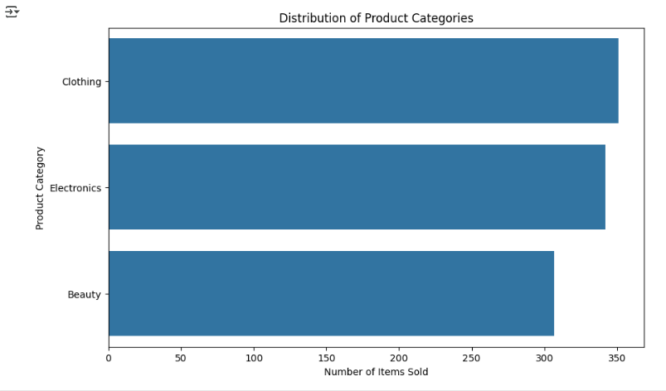

**Region:**

female are the gender which is contributing the most to sales. This could indicate a potential target market for specific marketing campaigns

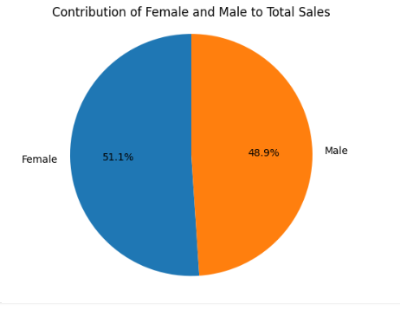.

**Correlation Analysis:**

A strong positive correlation exists between Quantity and Total Amount.

This is expected as purchasing a larger quantity of items naturally leads to a higher total spending.

A scatterplot was used for better visualization:

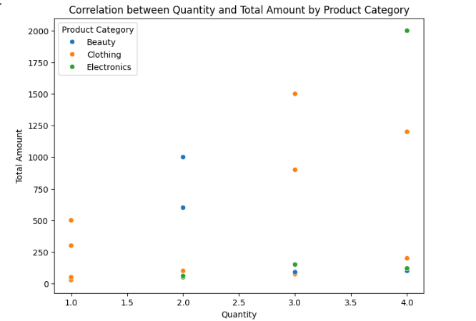

**Pie chart :**

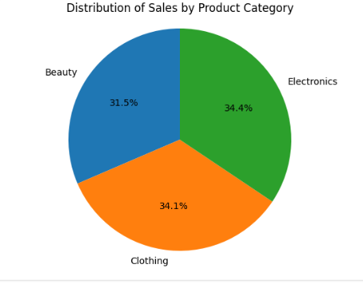

**Sales Distribution:**

The analysis revealed insights into the distribution of sales across different product categories, regions, and time periods.

By examining these patterns, businesses can identify potential areas for improvement.

**Recommendations:**

**✅ Since clothing products are in high demand, focus on strong marketing strategies to attract more customers.**

**✅ Use digital marketing, social media ads, and influencer promotions to reach a wider audience.**

**✅ Identify regions with high sales and expand operations there.**

**✅ Adjust marketing strategies based on regional customer preferences to boost sales.**

**✅ Introduce special promotions, discounts, and combo offers to encourage bulk purchases.**

**✅ Create seasonal or festival sales to attract more customers and increase revenue.**

**✅ Conduct surveys and analyze customer feedback to understand purchasing behavior.**

**✅ Improve product recommendations and customer service based on customer needs.**